Evaluating the Mashgin Checkout System
Deployment, Recommendations, and Lifecycle Management
BAN 888: Implementing Analytics for Business
Penn State Smeal College of Business
Part III — Analytics Model Solution Deployment and Lifecycle Management
Aditi Jyoti Prakash Behera, Manoj Kuntamukkula, and Eric Matthew Smith
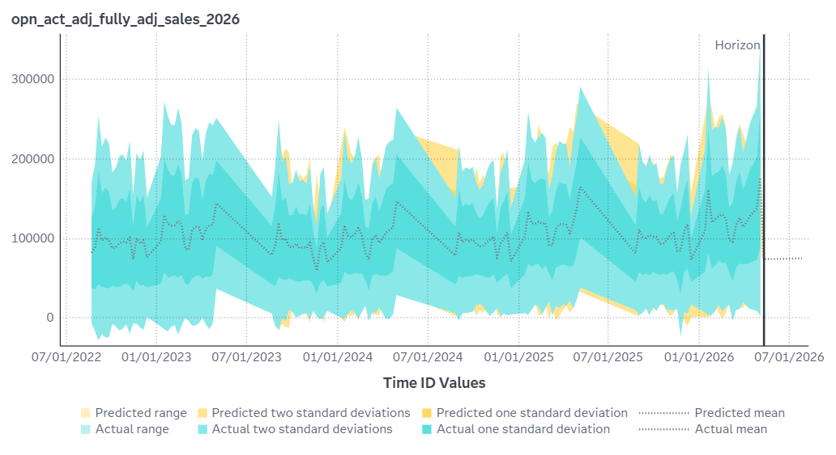
Final fully adjusted weekly sales forecast (SAS Viya). Repeated rises and declines reflect the academic-year cycle rather than a system-driven trend.

1. Executive Summary
In 2024, Penn State Auxiliary and Business Services (ABS) began replacing legacy point-of-sale registers with Mashgin, an AI-powered self-checkout system, across its University Park convenience-store network. This report answers the question for ABS leadership: did Mashgin improve sales? It did not, but the transition went smoothly, sales held steady, and the system delivered clear gains in checkout speed.
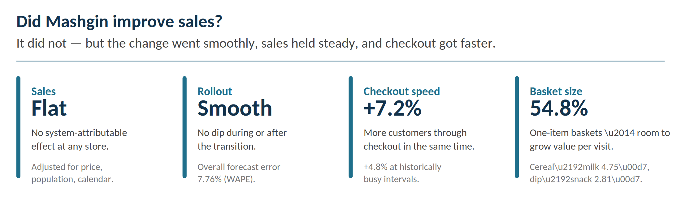
The final SAS Viya forecasting models, built on weekly data from August 2022 through May 2026 across the four comparable stores (South, East, Pollock, and West), scored well enough to trust this read, with a sales-weighted overall Weighted Absolute Percentage Error (WAPE) of 7.76% (roughly $7.76 of forecast error for every $100 of actual adjusted sales) and every store below 10%. No champion model retained the legacy-system indicator; sales are explained instead by each store’s recurring academic-year seasonal pattern. In short, the switch neither raised nor lowered sales but reflected a smooth, no-disruption rollout.
One store, Pollock, initially appeared to be an exception as an earlier modeling run retained the system indicator there. That signal disappeared once the underlying records were corrected for operational open times, so partial-open weeks could be cleanly compared against full weeks. After the correction, the model didn’t find that the difference before and after Mashgin was implemented as signficant. The finding therefore points to insufficient evidence of a distinct sales effect from the system change.
Where Mashgin did deliver was in checkout speed. During the Mashgin period, transaction flow during comparable active windows rose an adjusted +7.2% overall and +4.8% during historically busy intervals: the stores moved more customers through checkout in the same amount of time, with attendants monitoring and assisting rather than operating registers. The system worked as intended with faster checkout, but that speed did not translate into higher sales. Stable sales alongside higher throughput points to the natural next study: a cost analysis weighing the system’s licensing and hardware cost against the staffing savings from that shift. That comparison is outside this phase’s scope, but it may be worth exploring and is something that senior operational managers have expressed an interest in.
We further looked into what items students purchased together, pointing toward opportunities for ABS in merchandising. A market-basket analysis of 298,344 Mashgin transactions identifies concrete, testable actions and strong cross-category pairings, such as cereal with milk (4.75 times more often than chance) and dip with salty snacks (2.81 times), specific product bundles, and a notable finding that Pollock functions as a “gateway” store to athletics housing and other hosing in South, drawing roughly half its customers from outside its own housing area. That makes Pollock a strong candidate for product placement and bundle pilots.
The sections that follow document how the adjusted weekly figures were built period by period, including the open-times correction, what the forecasting models found for each store, what the throughput and basket analyses added, and a plan for deploying the merchandising recommendations and tracking their effect over time.
Table 1. Final Fully Adjusted Weekly Sales Model Fit
Scope | Location | Champion model | WAPE
Store forecasts | Pollock | Additive Winters | 5.61%
Store forecasts | West | Seasonal ARIMA | 8.18%
Store forecasts | East | Seasonal ARIMA | 8.42%
Store forecasts | South | Seasonal ARIMA | 9.11%
Network | Overall | — | 7.76%

2. Problem Statement
In 2024, ABS began phasing Mashgin into its University Park convenience-store network. Mashgin is an AI-powered self-checkout system where customers place all items on a scanning surface, the system identifies them at once, and the customer pays. There is no item-by-item barcode scanning. Instead of operating a register, a Customer Service Representative monitors several units, handles exceptions, and supports payment compliance. The expected value is faster checkout, higher throughput at peak, and a better use of staff time.
The business question is direct: did Mashgin improve sales? A preliminary Phase I hypothesis test hinted that stores were handling more purchases, but customers were spending less per purchase, which raised a second, linked question: if visits are faster and smaller, what can ABS do to raise the value of each visit? The project therefore has two parts, which are a performance evaluation of the sales question, and a market-basket study of the value-per-visit question.
Scope has held steady since Phase II. The analysis covers four comparable convenience-store locations — South, East, Pollock, and West. A fifth location, North, remains excluded because its convenience-store sales cannot yet be separated cleanly from full-service dining activity. One scope refinement carried into this final phase. The modeling window is restricted to regular open-semester weeks, with between-term periods, summer camps, training weeks, and other nonstandard operations held out so the comparison reflects normal store operations rather than closures.

3. Description of Data
The analysis draws on several sources, each cleaned and validated for a specific role. The two transactional backbones are the legacy MICROS point-of-sale system (about 3,065,933 transactions, Aug. 2022–July 2025) and the Mashgin system (about 3,953,932 transactions in the new-system period). Supporting sources supply the context needed to compare fairly across time: matched item prices by semester, nearby residential population, and the academic calendar.
Table 2. Data Sources and Validation Controls
Category | Data source | Role in the analysis | Validation applied | Value to the analysis
Transaction data | Legacy MICROS SQL | Historical sales, transactions, dates, and store names | Monday-start weeks; standardized location, tender, and check logic | Repeatable pre-Mashgin baseline
Transaction data | Mashgin API / vendor output | New-system sales and transaction records | Staged and checked before use as the analytical source | Traceable new-system dataset
Validation & staging | Mashgin cloud reporting / JSON | Dashboard totals used for verification | Used as a validation check rather than the modeling source | Flags API pulls that do not reconcile to vendor totals
Validation & staging | C# importer and SQL staging | Repeatable path from source files into SQL tables | Files parsed, loaded, reviewed, and staged before aggregation | Auditable pipeline rather than one-time exports
Adjustment data | Matched item price file | Semester-level prices for comparable items | Prices matched across terms to build multipliers | Separates real performance from price increases
Adjustment data | Population and academic calendar | Nearby population, breaks, and closure context | Multipliers, break indicators, and inactive-week flags added | Keeps population shifts and breaks out of the Mashgin comparison

The Mashgin feed required the most care. Its API could run slowly and truncate records while still returning success messages, so a technically “good” pull could be silently incomplete. The team verified API pulls against Mashgin’s own reporting dashboard and the data (JSON) behind it, and built a custom C# importer with throttling, record-count validation, and retries. Reconciling to vendor totals matters because a model can look precise while running on partial data.

4. Overview of the Data

The cleaned modeling dataset is a weekly store-level result: one row per store and system per week, spanning August 2022 through May 2026, with raw sales and transaction measures, system-period indicators, price and population multipliers, adjusted-sales fields, and academic-calendar controls. The table below summarizes the key quality checks.
Table 3. Cleaned Data Summary and Quality Checks
Category | Area checked | Result | Why it matters
Scope | Stores included | South, East, Pollock, West | Comparable convenience-store operations only
Scope | Date range | Aug. 2022-May 2026 | Covers both legacy and Mashgin periods
Coverage | Legacy / Mashgin weeks | 392 / 323 | Substantial comparison periods on both sides
Data quality | Negative sales or transactions | None found | No invalid operating values in the model
Adjustments | Price multiplier range | 1.000-1.143 | Reasonable semester-level price movement
Adjustments | Population multiplier range | 0.725-1.217 | Expected shifts in nearby student population
Adjustments | Open-days adjustment | Days open out of 7 | Allows partial weeks to be compared fairly with full weeks

The most consequential modeling decision was to leave nonregular operating weeks blank rather than zero. Between-term periods, summer camps, and training weeks are outside normal operation; zero-filling them would make them look like real low-sales weeks and bias the comparison downward. Leaving them missing keeps the model focused on normal store operations. As described in Section 5, this same principle, distinguishing “closed or partial” from “open and underperforming,” is what ultimately corrected the Pollock result. Making sure that weeks where one day was open out of seven, for example, by dividing sales by the percentage of the week the store was open, allowed that one day to compare fairly with a full week of sales for forecasting purposes.

5. Description of Transformation of Data
Raw sales alone cannot answer the sales question, because two things moved over the study period that have nothing to do with Mashgin. Prices rose, and the nearby student population shifted. Two multipliers put every week in comparable terms. A price multiplier, built from a matched basket of common items each semester and anchored to the Spring 2026 base (= 1.000), expresses every period in comparable dollars. A population multiplier, built from each store’s nearby student count, normalizes for changes in the surrounding customer base. Applying both yields fully adjusted weekly sales, with price and population effects stripped out.
The academic calendar is layered on top. Normal class weeks, Spring Break, Thanksgiving, graduation, the gap between semesters, and summer shutdown each affect sales differently, so each week is flagged along with how many days a location was actually open and how active the week was.

A correction that improved the forecasts
An earlier version of the adjusted-sales series applied the partial-day adjustment incorrectly. When a location was open only part of a week, and it was an opening or closing ramp week, or a holiday-shortened week, that week still carried a full week’s worth of expected sales against only a partial week’s actual sales, so it read as underperformance rather than as reduced operating time. The fix was to bring partial weeks up to full-week equivalence using an open-percentage index: each week is scaled by the share of the week the location was actually open, so a store open 60% of a week is compared on the same footing as one open the full seven days. This lets partial weeks sit alongside full weeks in the same series instead of being discarded or dragging the trend down.
The correction had two effects. First, it improved forecast accuracy, because the models were no longer fitting to artificial dips created by partial-open weeks. Second, and more consequentially for the business question, it removed a false signal at Pollock. In the uncorrected series, Pollock’s model retained the legacy/Mashgin indicator, which looked like a genuine system effect. Once the open-percentage index was applied, that indicator dropped out, and the final run retains it at no location. The apparent exception was an artifact of how partial weeks had been handled, not a real Mashgin effect. It is a case where a single adjustment changed the conclusion, which is exactly why the adjustment steps are treated as critical.

6. Analysis of Data

6.1 Modeling approach
Because the data is ordered by week and store performance follows a strong campus rhythm, the team used time-series forecasting rather than treating each week as independent. SAS Viya’s automatic forecasting let ARIMA-family, ARIMAX/REGARIMA, and exponential-smoothing models compete per store, with a holdout window used for champion selection so models were judged on data they were not fit on. Each store was modeled separately, as East, Pollock, South, and West differ in location and demand, and pooling them would hide exactly the store-level differences the analysis is trying to detect. In the sales model, fully adjusted weekly sales is the dependent variable and the system-period indicator is tested as an outside input on a “use if significant” basis; price and population multipliers are not reused as inputs because they are already built into the dependent variable.

6.2 What the final models chose
SAS selected a location-specific champion for every store, and every champion explicitly incorporates recurring seasonality. Crucially, no champion retained the legacy indicator or any other independent input. The recurring semester rise, plateau, and decline were already captured by 52-week seasonal differencing (East, South, West) or additive Winters seasonality (Pollock), so the proposed semester-ramp variable did not add ot the story and was not retained either.
Table 4. Champion Model by Location
Model family | Location | Executive interpretation
Seasonal ARIMA | East | Recent sales patterns plus the annual academic cycle  Annual campus seasonality with one short-run autoregressive term  Recurring semester structure with short-lived shocks
Seasonal ARIMA | South
Seasonal ARIMA | West
Exponential smoothing | Pollock | Level, trend, and additive seasonality; strongest forecast accuracy

Figure 1. Final fully adjusted sales forecast envelope. Repeated rises and declines are seasonal, not a monotonic system-driven trend.

6.3 Forecast accuracy
Forecast accuracy was measured using WAPE, which shows how far the forecasts were from actual sales. The overall WAPE was 7.76%, meaning the forecasts were off by about $7.76 for every $100 of actual adjusted sales. In addition, each store’s selected model performed better than a basic benchmark forecast based on prior sales patterns.

6.4 Throughput: the system did get faster
The sales models found no statistically significant change in adjusted sales attributable to Mashgin. A separate binomial regression examined how many checkout transactions began during each 15-minute period before and after implementation. After accounting for differences in operating conditions, the Mashgin period showed a 7.2% increase in checkout activity overall and a 4.8% increase during the busiest periods. In practical terms, the stores were able to move more customers through checkout in the same amount of time. This supports the operational benefit Mashgin was intended to deliver – greater speed and capacity – even though it did not produce a measurable change in the sales trend.
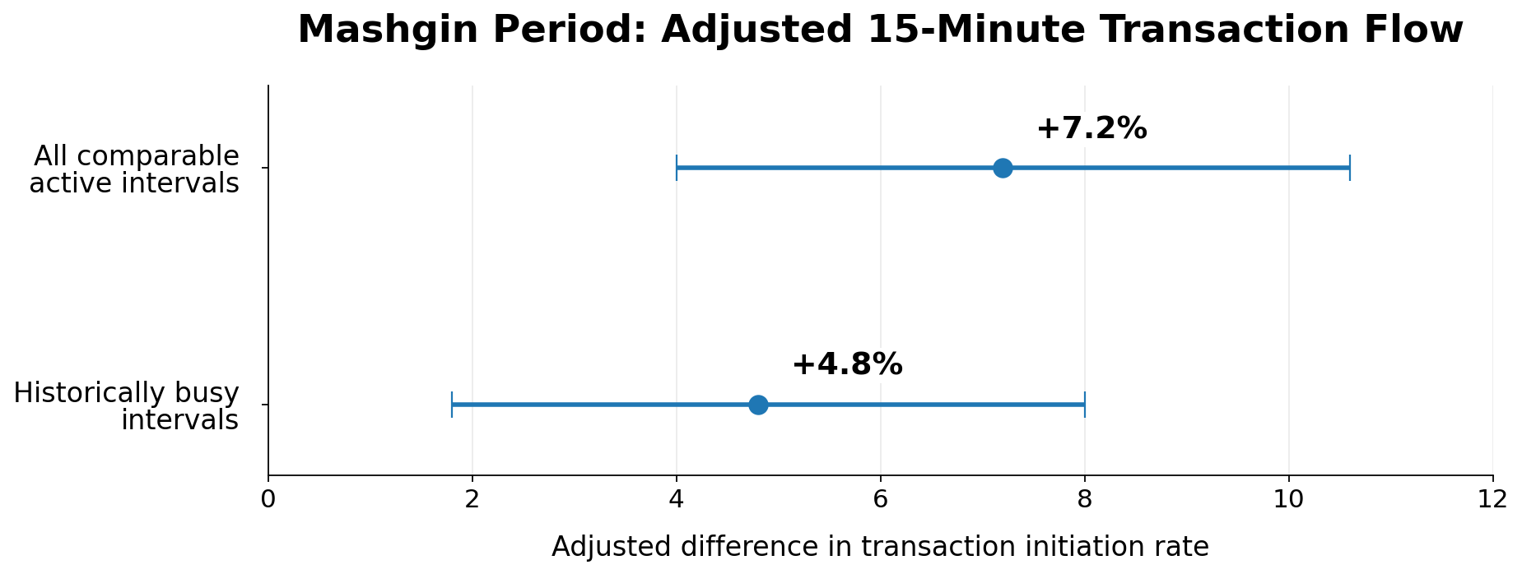
Figure 2. Adjusted transaction flow during the Mashgin period. Point estimates with intervals for all comparable active intervals (+7.2%) and historically busy intervals (+4.8%).

6.5 Market basket: where the value-per-visit opportunity lives
If faster checkout does not raise sales on its own, the lever ABS still controls is merchandising. A market-basket analysis of the April 2026 Mashgin item data, consisting of 514,379 cleaned transaction-item rows across 298,344 transactions and 4,174 distinct items, confirms that convenience-store visits are small and quick. We found that 54.8% of baskets contain a single item, and the average basket holds 1.72 unique items. That is precisely why add-on merchandising is the opportunity.
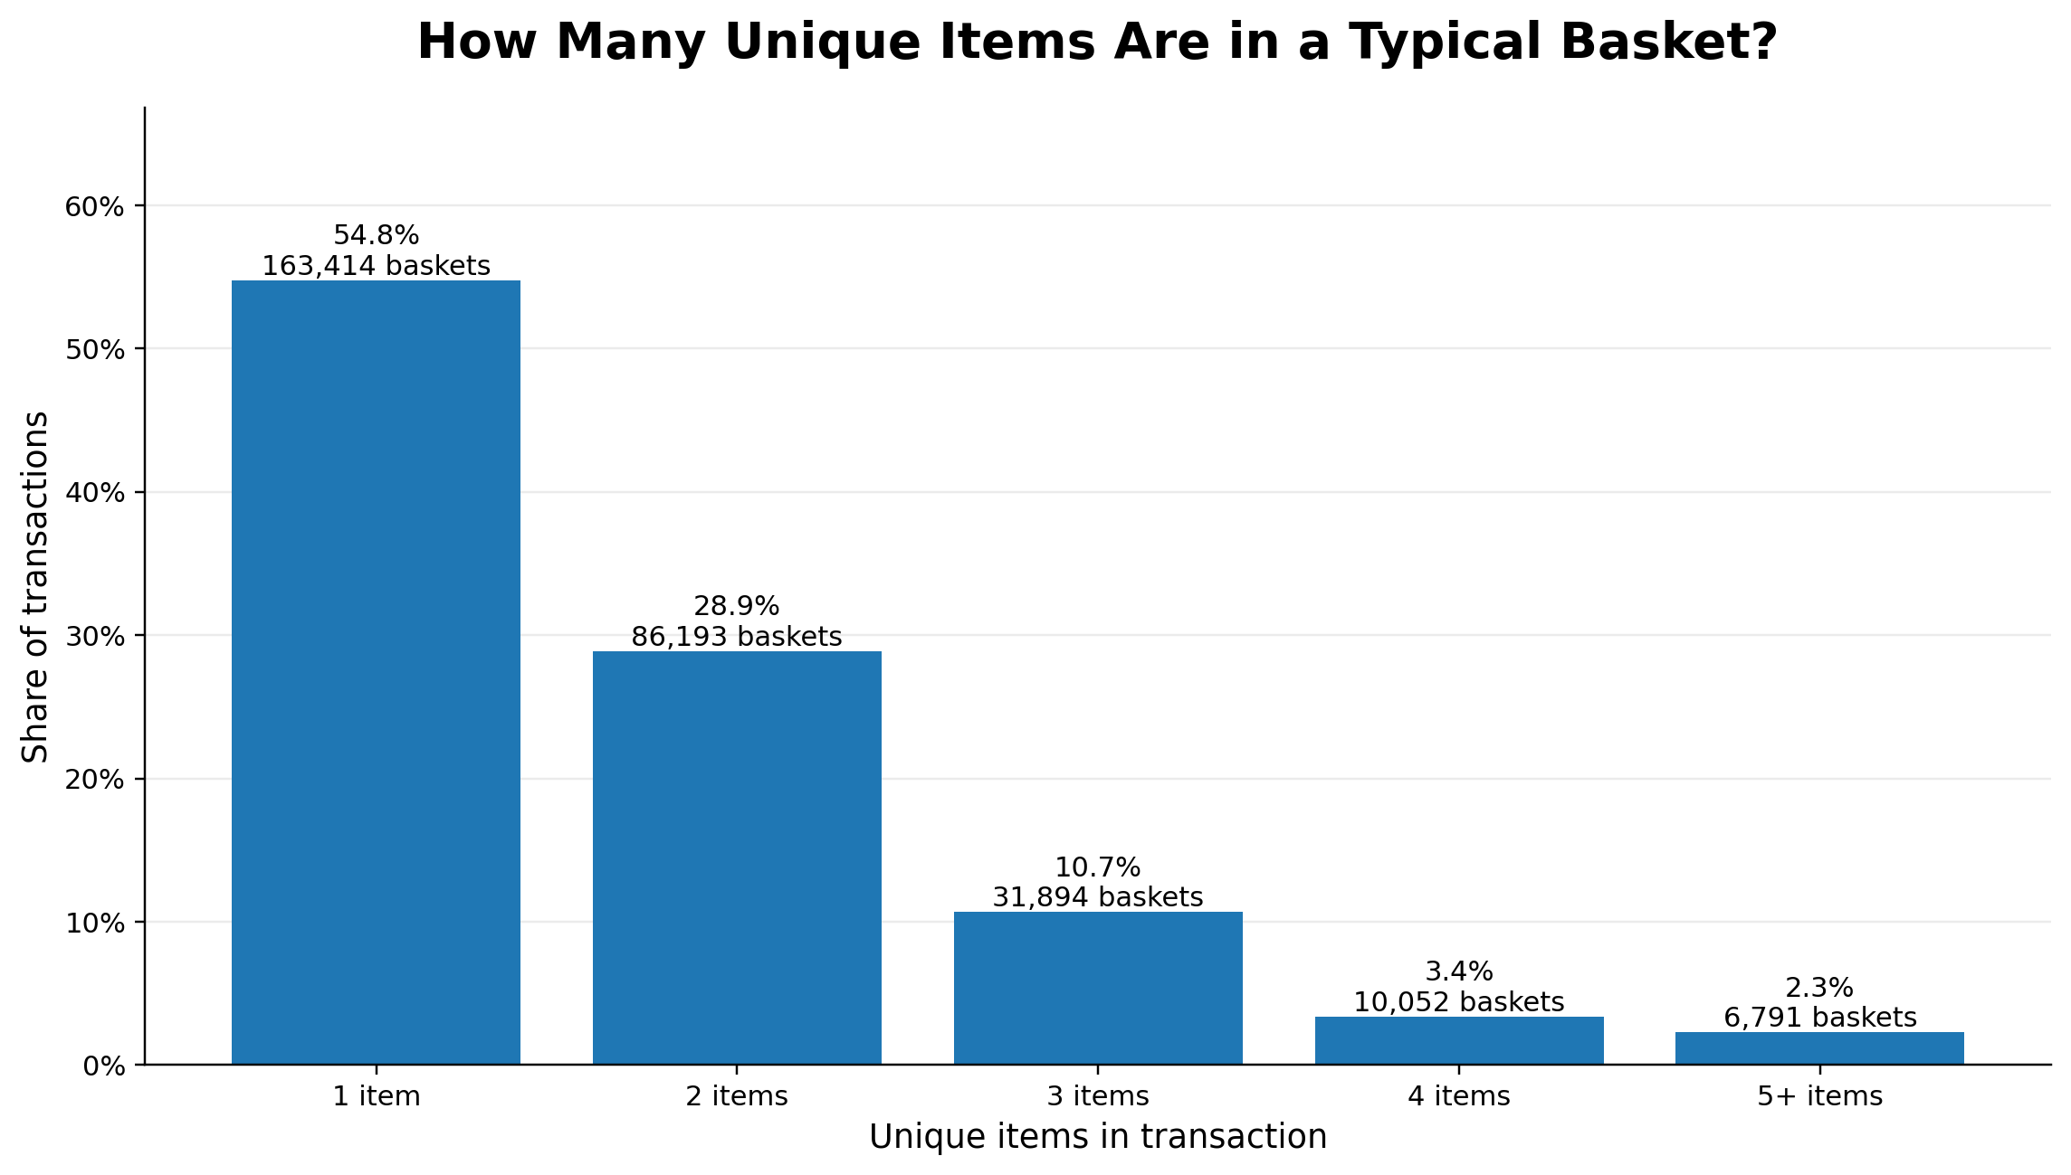
Figure 3. Basket-size distribution. Over half of all transactions contain a single item, underscoring the room to grow value per visit.
At the category level, the strongest, most actionable pairings are intuitive and easy to act on with placement and signage: Dip/Spread combined Salty Snack (2.81× lift) and Cereal/Breakfast and Milk/Dairy Drink (4.75× lift) lead the list, with yogurt combined with fruit and several prepared-food combined with snack pairings close behind.
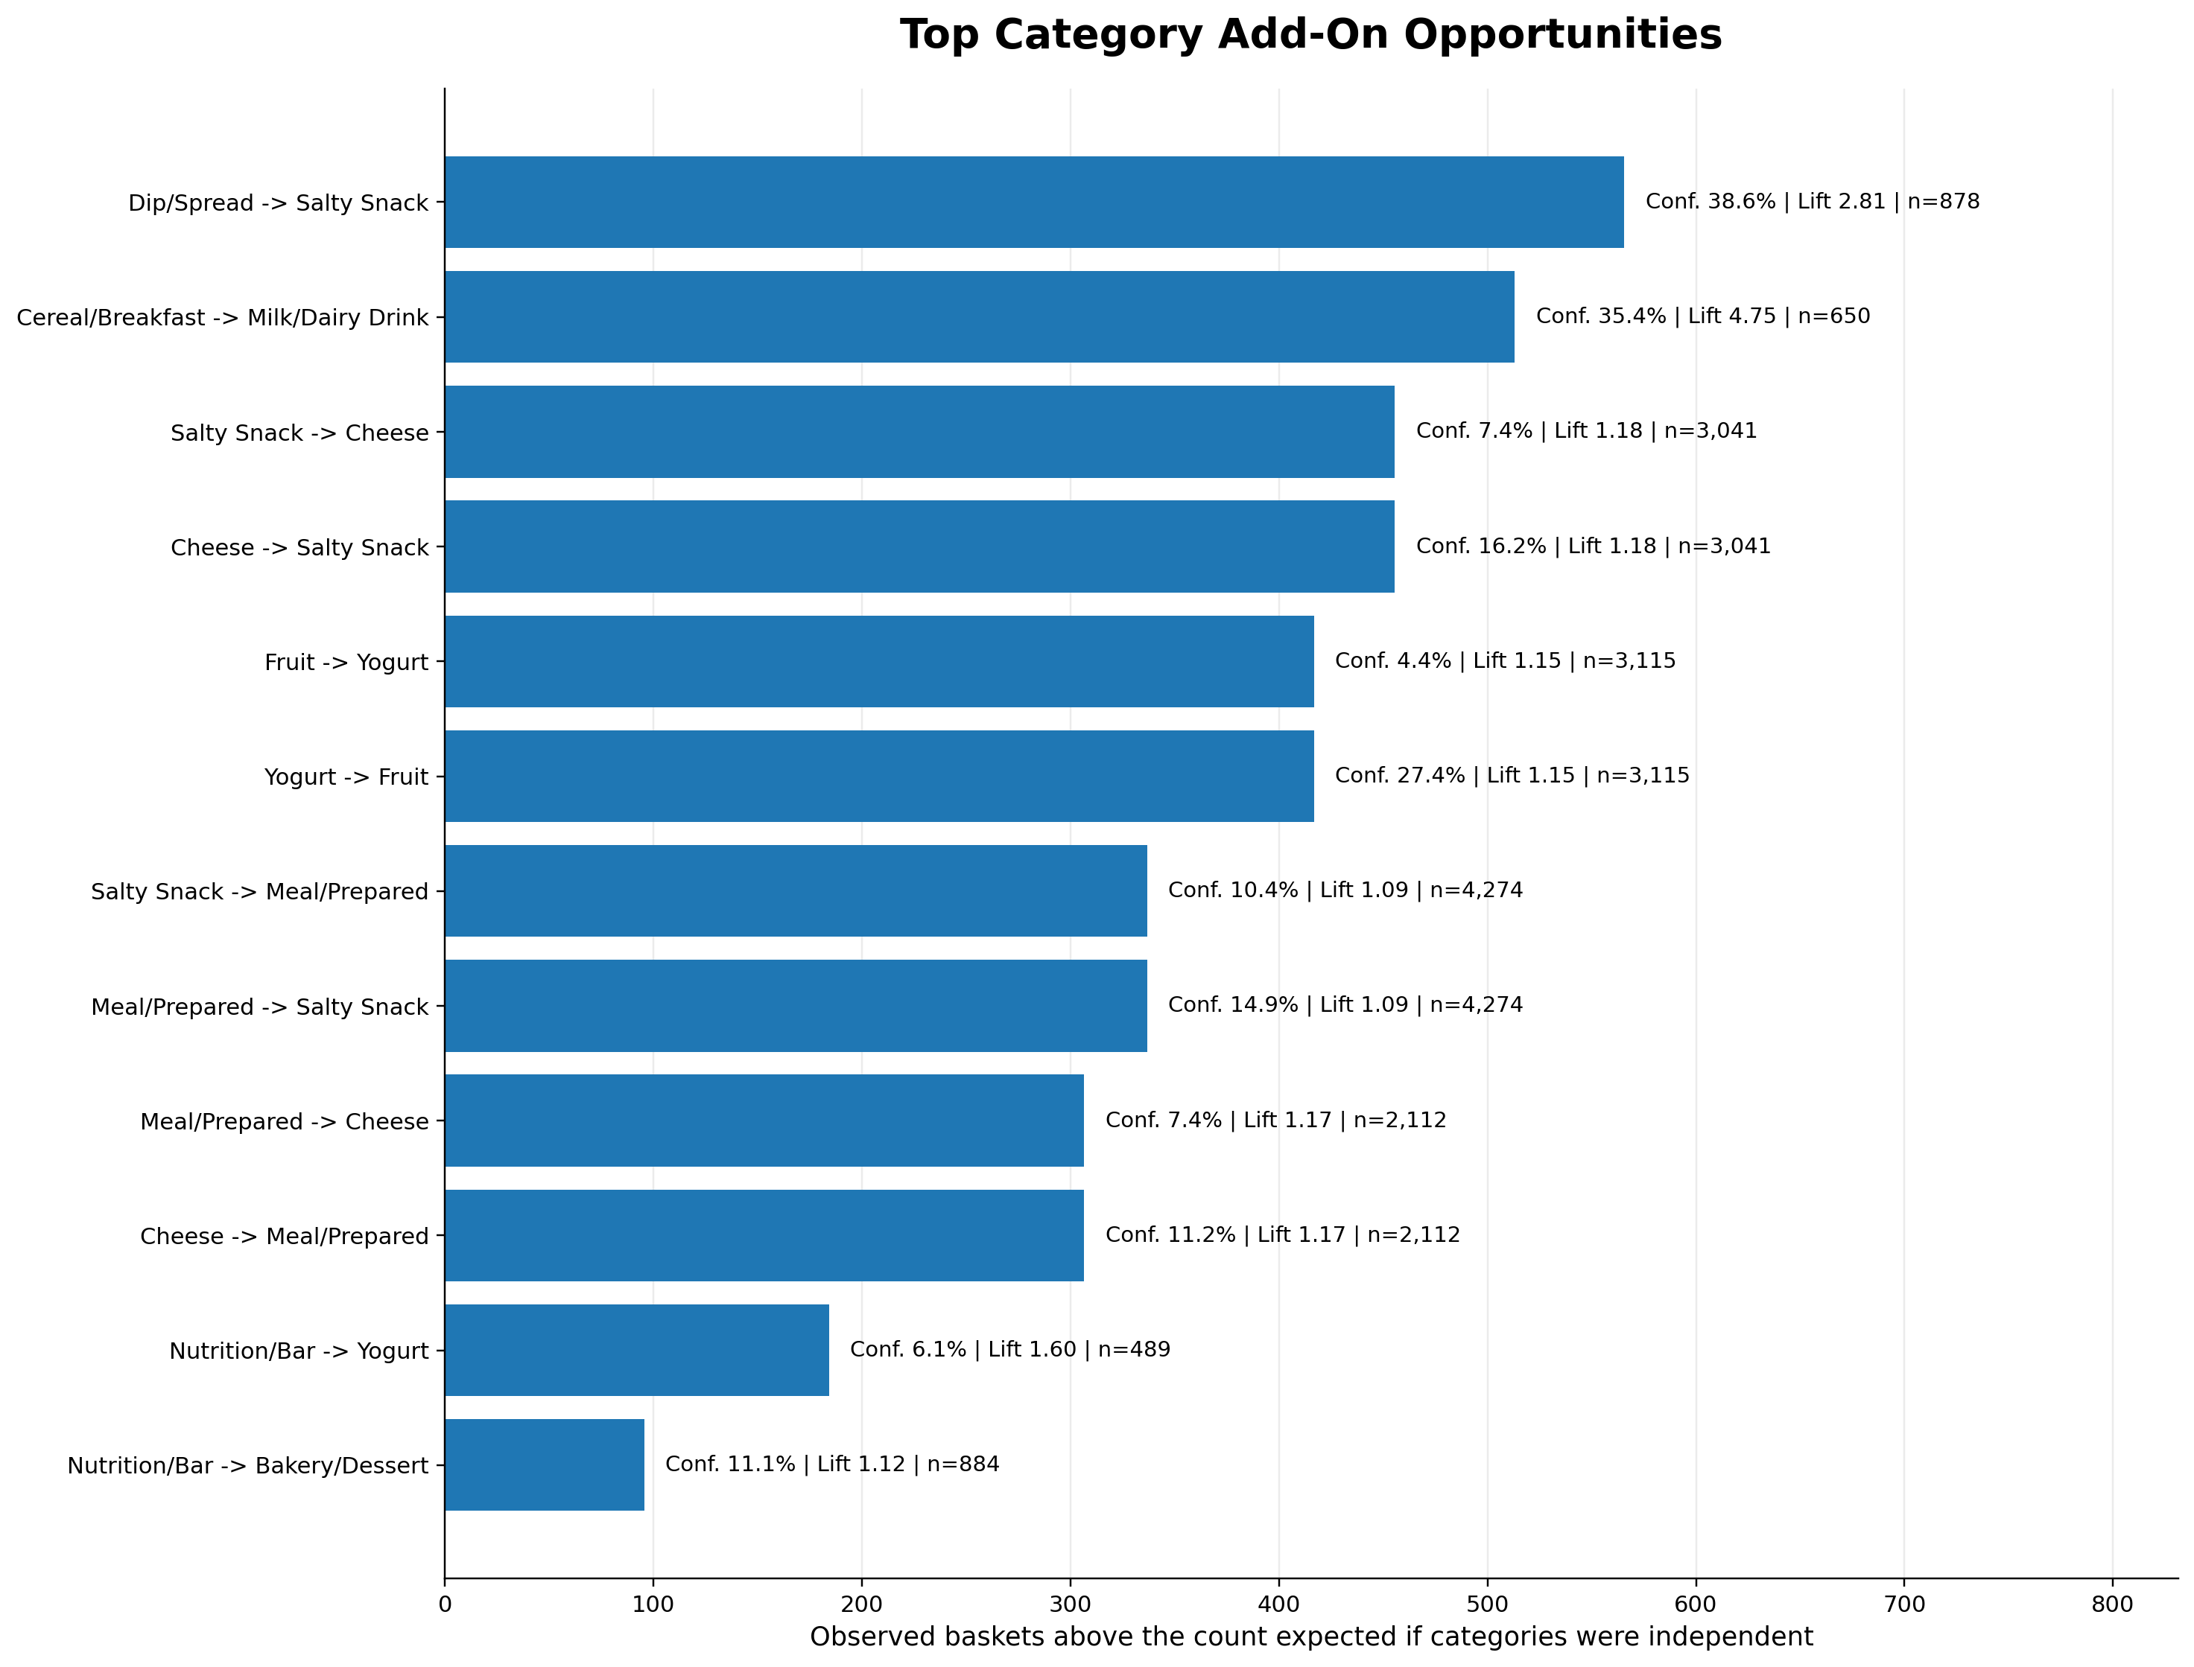
Figure 4. Top category add-on opportunities, ranked by baskets above the count expected if categories were independent.
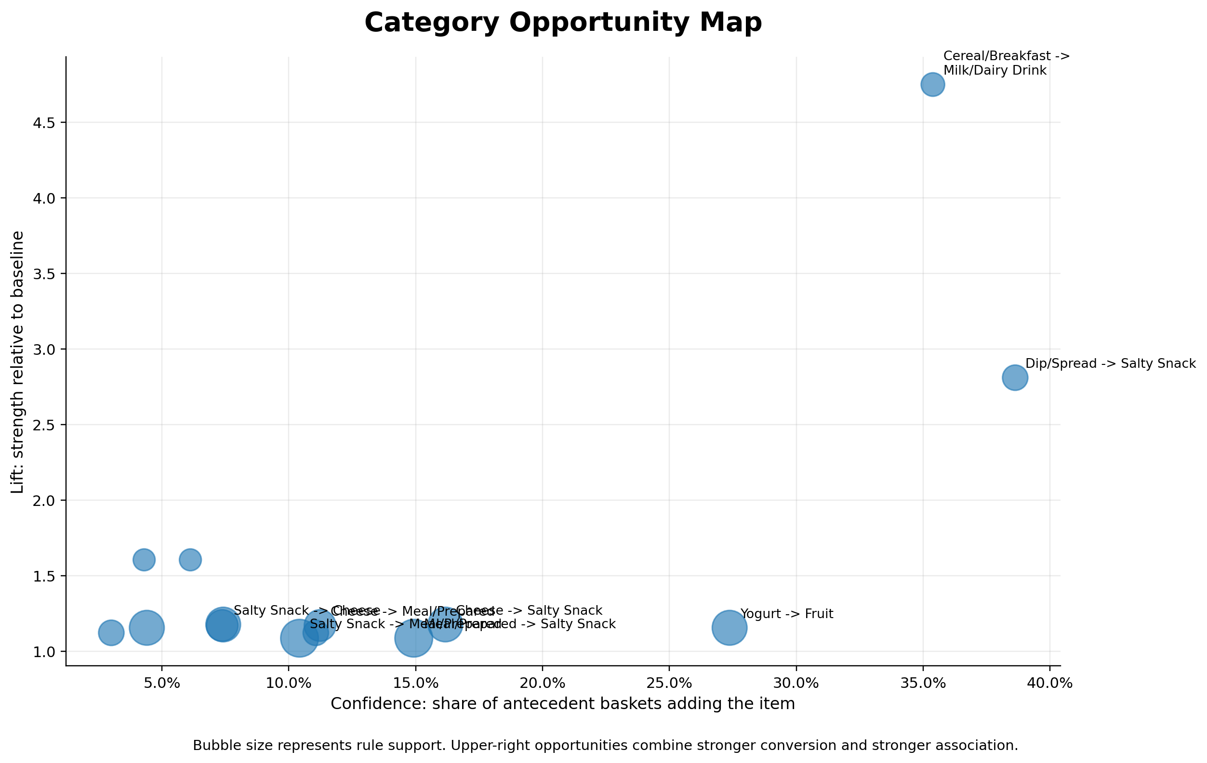
Figure 5. Category opportunity map. Upper-right pairings combine stronger conversion (confidence) with stronger association (lift); Cereal→Milk and Dip→Salty Snack stand out.
The analysis also distinguishes true cross-category bundle opportunities from same-family variety behavior (a customer buying two flavors of the same product), which is a weaker case for cross-selling. SKU-level pairings surface concrete bundle candidates – for example, specific chip-and-dip and cereal-and-milk combinations – that managers can test directly.
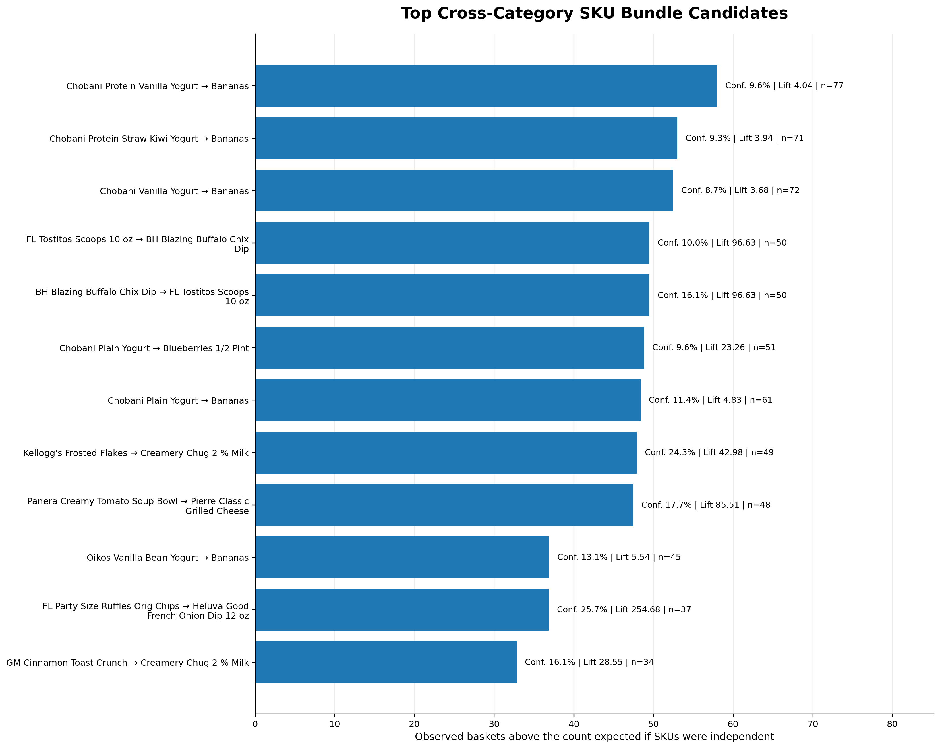
Figure 6. Top cross-category SKU bundle candidates for placement and promotion testing.

6.6 A location finding: Pollock is a gateway store
Listening to the data on customer origin surfaced a finding ABS did not ask for but can use. Pollock draws roughly half of its customers (49%) from housing areas other than its own – far more than East (11%), West (22%), or South (38%). Transactions from other residence areas nearly matched Pollock-area residents in both semesters, so Pollock functions as a gateway location that a broad cross-section of campus passes through. That makes it the strongest candidate for merchandising pilots: a placement or bundle test there reaches more of campus than the same test anywhere else.
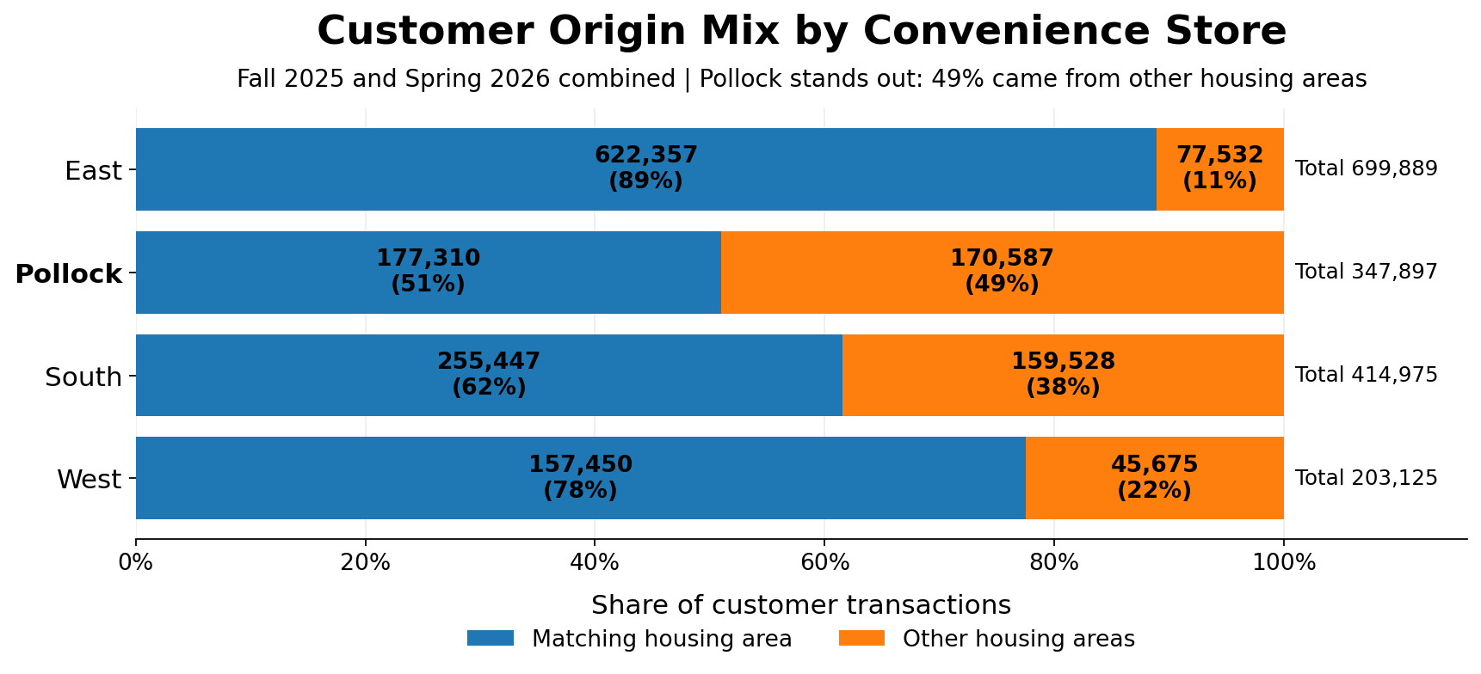
Figure 7. Customer origin mix by store. Pollock stands out: 49% of its transactions come from other housing areas.
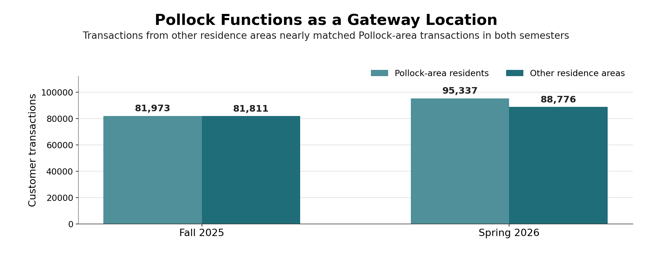
Figure 8. Pollock as a gateway location. Transactions from other residence areas nearly matched Pollock-area residents in both semesters.

7. Conclusions
The models are accurate, and they make sense. A sales-weighted WAPE of 7.76% with every store under 10% and the forecasts are trustworthy for planning, and the champion algorithms, seasonal ARIMA and additive Winters, are exactly what one would expect for weekly campus retail governed by an academic calendar. The recurring rise, plateau, and decline each semester are real and well captured.
The main conclusion is that there is no statistically supported, system-attributable change in adjusted sales. No champion retained the legacy indicator; sales are explained by seasonal and week-to-week structure, not by the checkout system. The right way to state this is careful: the modeling process found insufficient evidence of a distinct system effect after accounting for time-series patterns.
The one counterintuitive result along the way that Pollock, initially retaining the system indicator, turned out to have a clear explanation. It was an artifact of partial-open weeks that had not yet been corrected for operational open time. Once corrected, Pollock no longer stood out as different than the others. This is worth flagging precisely because it is the kind of finding that, left unexamined, could have been misreported as a real Mashgin effect. It is a reminder that the adjustment steps are not cosmetic.
None of this means Mashgin failed. It means Mashgin’s value is not in the sales line, and was never likely to be. The throughput analysis shows the system doing exactly what it was bought to do – moving customers through checkout faster – while the staffing model shifts from register operation to monitoring and assistance. Whether that speed-and-staffing value exceeds the system’s cost is a genuine open question, and it is a cost question, not a sales question. Finally, the basket work shows that if ABS wants to raise the value of each faster visit, the tools are merchandising ones: placement, signage, and bundle tests, starting at Pollock.

8. Recommendation
The information can help with action along three tracks: keep the sales model running as a monitoring tool, run the merchandising tests the basket analysis points to, and back the cost study that the sales result makes unavoidable. The first two are detailed below as a deployment plan and a lifecycle-management plan, as required; the third is scoped as the recommended next project.

8.1 Deployment plan
Two practical next steps are recommended: use the forecasting models as an ongoing management tool, and test the merchandising opportunities in the field.
- Turn the forecast into a weekly operating tool. The data pipeline already brings together sales, pricing, population, operating hours, and the academic calendar. Refresh it each week and update the SAS Viya models on a regular schedule so managers have a current forecast for every store, not just a one-time analysis.
- Give managers a simple exception report. The models already account for normal seasonal patterns. Weeks that fall well outside the expected range should be flagged automatically so managers can focus on unusual results that may require action.
- Start the merchandising pilot at Pollock. Test the strongest and easiest opportunities first, including placing dips near salty snacks and cereal near milk, along with one or two of the leading product bundles identified in the analysis. Pollock’s broad campus traffic makes it the best location for an initial pilot.
- Measure the pilot from the start. Establish a clear baseline before making any changes, then track items per basket and adjusted sales per visit. This will show whether the recommendations produce a measurable business result rather than relying on observation or anecdote.

8.2 Model lifecycle management
A forecasting model decays as conditions change. The plan below keeps it honest and keeps the merchandising tests generating decisions over time.

Table 5. Model and Merchandising Lifecycle Plan
Management area | Activity | What happens | Cadence
Forecast operations | Refresh and re-fit | Refresh the weekly data and forecasts; confirm each store's champion still performs best. | Weekly; re-fit each semester
Forecast operations | Exception and accuracy watch | Flag weeks outside the forecast range and monitor WAPE; investigate sustained results above about 10%. | Weekly; semester review
Model governance | Indicator re-test | Re-test the legacy/Mashgin indicator as additional Mashgin history becomes available. | Annually
Model governance | Adjustment upkeep | Update price and population multipliers and retain the open-times correction. | Each semester
Merchandising tests | Pilot review | Review results, scale winners, stop weak tests, and select the next pilot. | Each 6-8 week cycle
Merchandising tests | Basket refresh | Re-run the basket analysis for changing pairings, new products, and seasonal opportunities. | Each semester

The governance point behind the table is the Pollock lesson: adjustments are what make the model trustworthy, so the lifecycle plan protects them explicitly. If the open-times correction or the price/population multipliers silently lapse on new data, a false signal can reappear — exactly as it did before correction.

8.3 Recommended study: cost
The sales result reframes the return-on-investment question rather than answering it. Because Mashgin’s value is operational, the decisive analysis is a cost study that sets the system’s licensing and hardware cost against the staffing savings from the shift away from register operation, using the throughput gains as the operational input. That study is outside this phase’s scope, but the weekly dataset, the staffing context, and the throughput measures assembled here are built to support it, and it is the recommended next engagement.

Appendix

A. Supporting figures
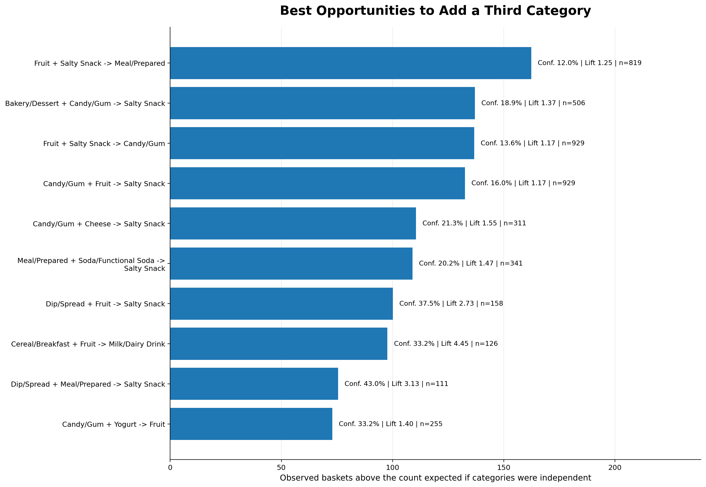
Figure A1. Best opportunities to add a third category to an existing two-category basket.
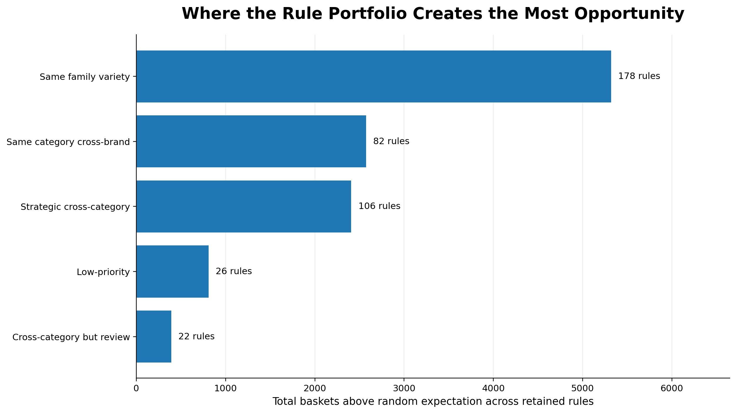
Figure A2. Where the rule portfolio creates the most opportunity, by recommendation class.

B. Methods and sources
- Forecasting: SAS Viya automatic forecasting was used to select the best-performing model for each store from ARIMA-family, regression-based, and exponential-smoothing candidates. Model selection was evaluated using a holdout period.
- Forecast accuracy: WAPE measures total forecast error as a percentage of total actual sales by dividing the sum of all absolute forecast errors by the sum of actual sales.
- Checkout throughput: A binomial regression compared the rate of transaction initiations before and after Mashgin across comparable active 15-minute periods. The analysis also examined historically busy intervals to determine whether Mashgin increased checkout capacity when demand was highest.
- Market basket analysis: A Python association-rule analysis was conducted using April 2026 Mashgin item-level data. Support, confidence, and lift were used to identify recurring product combinations with practical merchandising potential. The complete script is retained with the project files.
- Data adjustments: Weekly results were adjusted for semester price changes, nearby student population, academic-calendar effects, and actual store operating time. Spring 2026 served as the price-index baseline.

C. How the 15-minute throughput analysis was performed
The weekly forecasting models answered whether Mashgin changed adjusted sales. The Python analysis addressed a separate operating question: after allowing for normal differences in store activity, did more transactions begin within the same 15-minute period after Mashgin was introduced?
Table C1. Executive overview of the Python throughput analysis
Analysis step | What the Python script did | Why it matters
Comparable periods | Kept only store, weekday, and 15-minute clock periods represented under both the legacy and Mashgin systems. | Creates a fair before-and-after comparison.
Checkout-flow measure | Counted the number of transactions that began in each 15-minute interval. | Measures realized checkout flow within the same amount of time.
Negative-binomial regression | Estimated the Mashgin difference while accounting for store, weekday, time of day, season, and the underlying weekly trend. | Separates the system-period result from normal operating patterns and is appropriate for transaction counts.
Peak-period test | Ran the analysis for all comparable active intervals and again for the historically busiest time periods. | Shows whether the operational effect also holds when demand is highest.
Executive result | Converted the regression result into an adjusted percentage difference. | Produced the reported 7.2% increase overall and 4.8% increase during busy periods.

Method Summary: After the operating differences above were accounted for, more transactions entered checkout during the Mashgin period. This supports a conclusion of greater checkout capacity, while the separate sales models found no measurable change in adjusted sales.
The analysis measures transaction starts in active intervals. It does not directly measure customer wait time, the seconds required to complete an individual transaction, or whether Mashgin created additional customer demand.
The retained Python script connects to the SQL view, prepares the comparable intervals, runs the overall and busy-period models, and exports the supporting tables, charts, and regression results.

